1. After clear Bug O/P is Below:
2. <html lang="en">
3. <head>
4. <title>Document guvi
5. </title>
6. </head>
7. <body>
8. <div>
9. Lorem ipsum dolor sit amet consectetur adipisicing elit.
10. <div>
11. Guvi Geek Network
12. </div>
13. </div>
14. </body>
15. </html>

2. After clear Bug O/P is Below:

<html lang="en">

    <head>

        <title>Document guvi</title>

    </head>

    <Body>

    <div>

        Lorem ipsum dolor sit amet consectetur adipisicing elit.

            <div>

                Guvi Geek Network

            </div>

    </div>

        </body>

    </html>

1. Design a contact us form with all fields as required.

<html>

<head>

    <title>contact form</title>

</head>

<body>

    <h1>Contact us</h1>

    <p>Your name</p>

    <input type="text" id="username" required>

<p> Your email address </p>

  <input type="email" id="Email" required>

<p>Your message</p>

  <textarea id="Message" name="Message" rows="6" maxlength="3000" required></textarea>

  <br><button type="submit">Submit</button>

</body>

</html>

4. Use certain HTML elements to display the following in a HTML page.

<body>

       <ul><li>Programming Language</li>

           <ul type=circle>

               <li>JavaScript</li>

               <ol type="a">

                <li> Angular</li>

                <li>React</li>

                <li>Vue.js</li>

               </ol>

               <li>Python</li>

               <ol type="a">

                <li>Django Framework</li>

                <li>Flask Framework</li> </ol>

               </ol>

               <li>Java</li>

               <ol type="a">

            <li>Spring</li>

           <li> Maven</li>

           <li> Hibernate</li>

        </ol>

    </ul>

           </ul>

         <ul>

             <li>Database</li>

            <ul type=circle>

                <li>MySQL</li>

                <li>MongoDB</li>

                <li>MyCansandraSQL</li>

            </ul>

        </body>

    </html>

Output

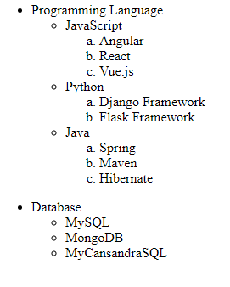

1. Create an element that helps you to open the [https://google.com](https://google.com/) in separate new tab.

Coding:

<a href="[https://google.com](https://google.com/)"> google.com!</a>

1. In the form, add two radio buttons with grouping them for employee type(Salaried and own business)
2. <body>
3. <input type="radio" id="emp"> Salaried<br>
4. <input type="radio" id="emp"> own business<br>
5. </body>
6. </html>

**O/P**

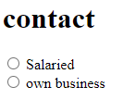

1. Design form shown in the link (<http://evc-cit.info/cit040/formguide/card_0.png>)

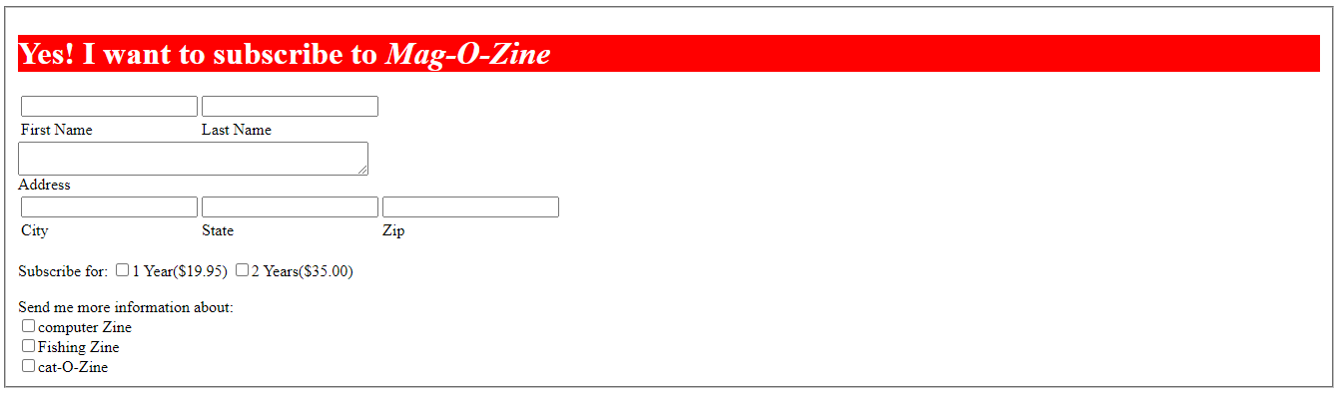

1. Use the table tag to design given image [Click here](https://www.bapugraphics.com/assets/img/port_upload_dir/table-4.jpg).

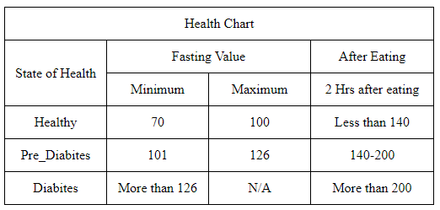

1. Write HTML input tags snippet to show default values for all Form elements.

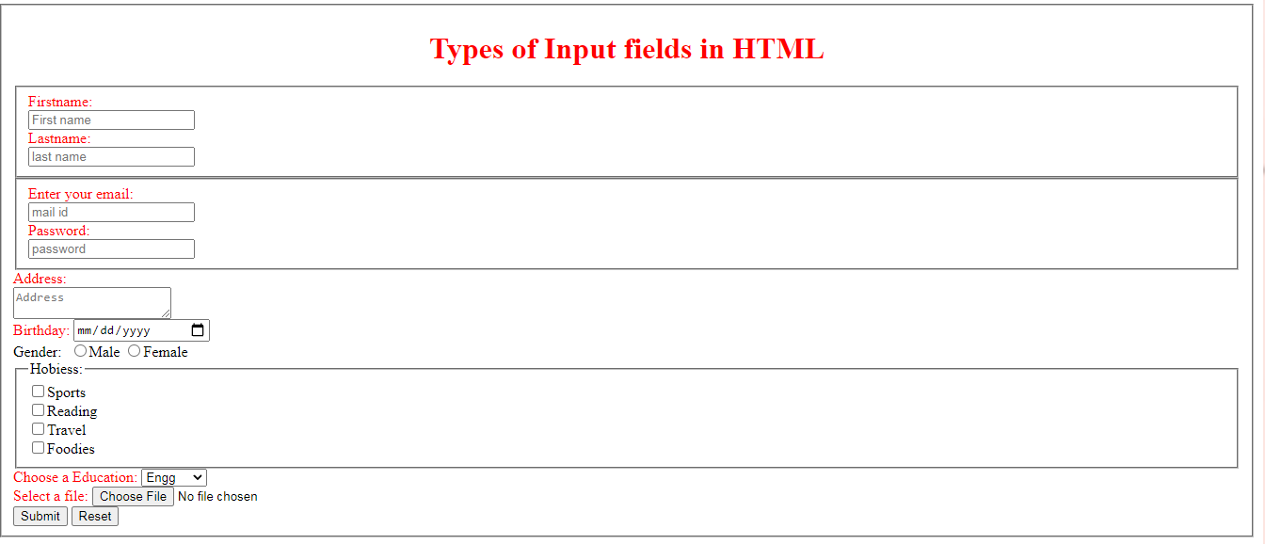

1. In your, HTML page add the below line and Highlight it without using any CSS.

* "HTML & CSS is awesome"

Code:

<ul>

     <li>

        <mark>HTML & CSS is awesome</mark>

     </li>

</ul>

Output:



1. Create an HTML page, which should contain all types of input elements.

